Lesson 3 Homework | LT 3.3 | 3-12, 17, 18, 21, 22, 24
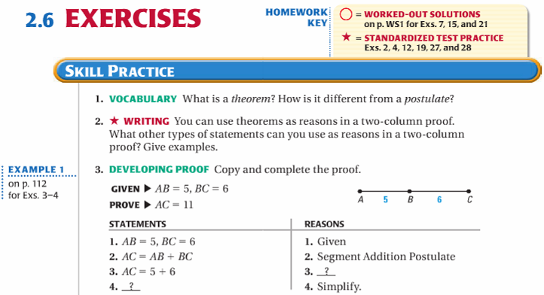

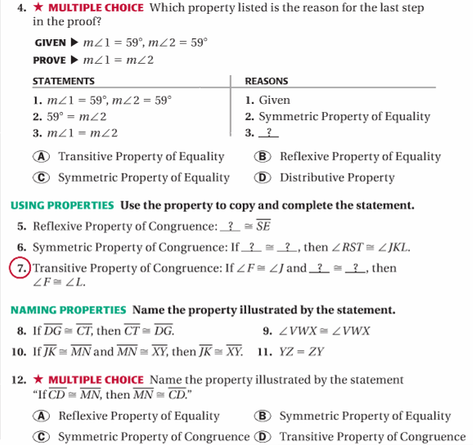

Lesson 3 Homework | LT 3.3 | 1-12, 17, 18, 21, 22, 24

